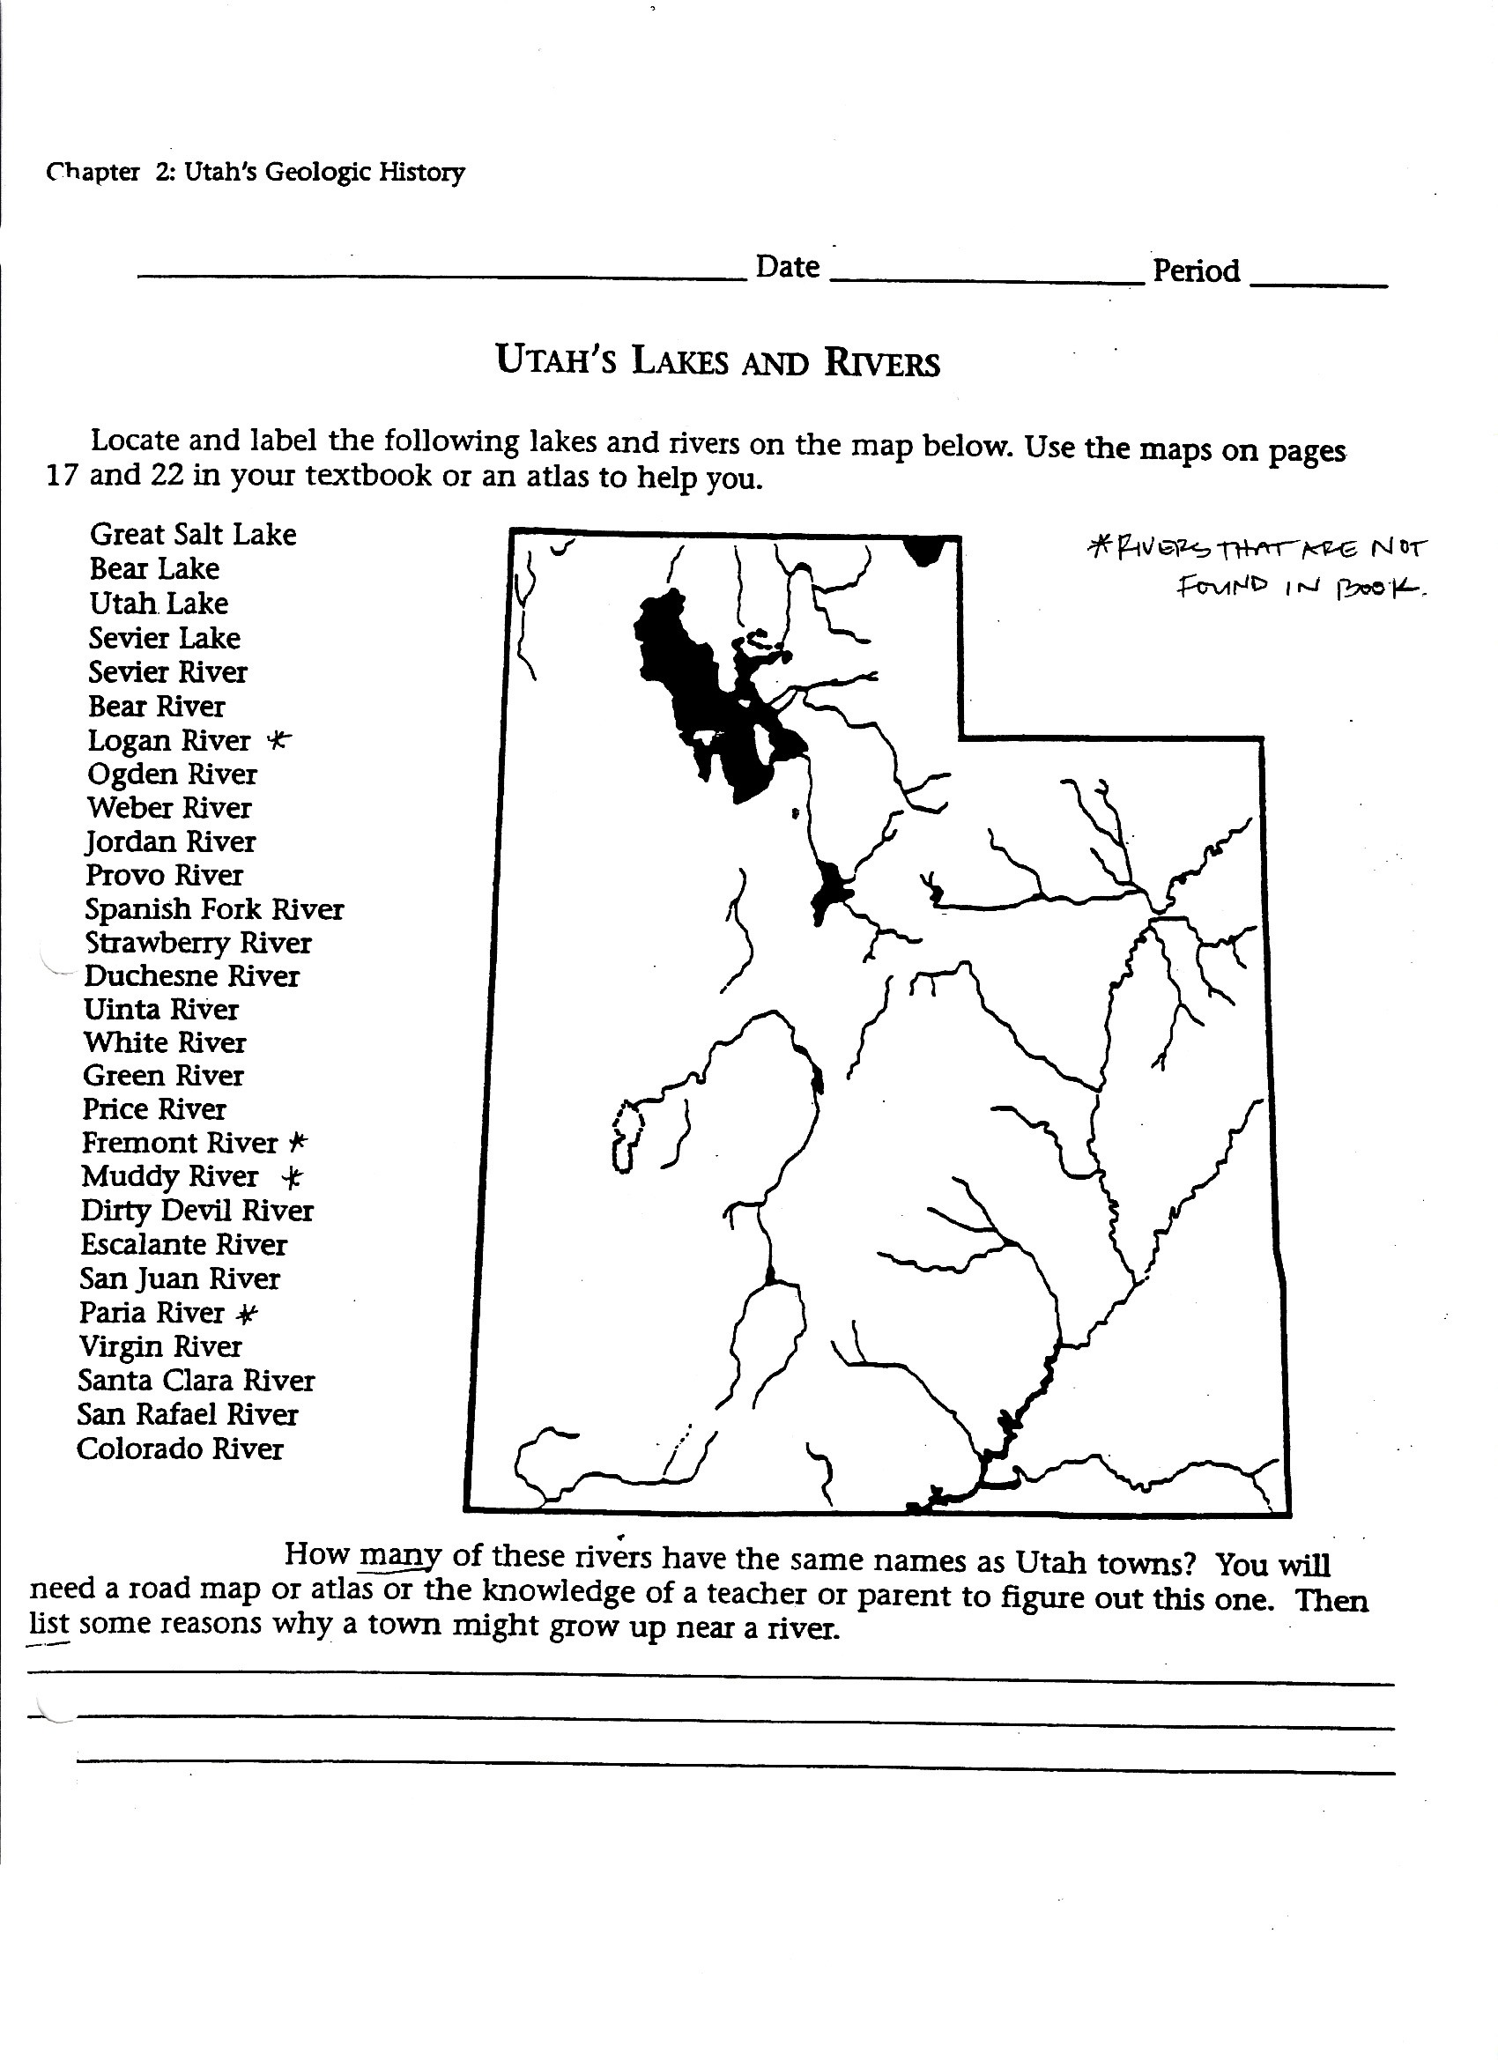

Locate and Label the following lakes and rivers on the map below. Use the maps on pages 9 and 25 in your textbook or an atlas to help you.

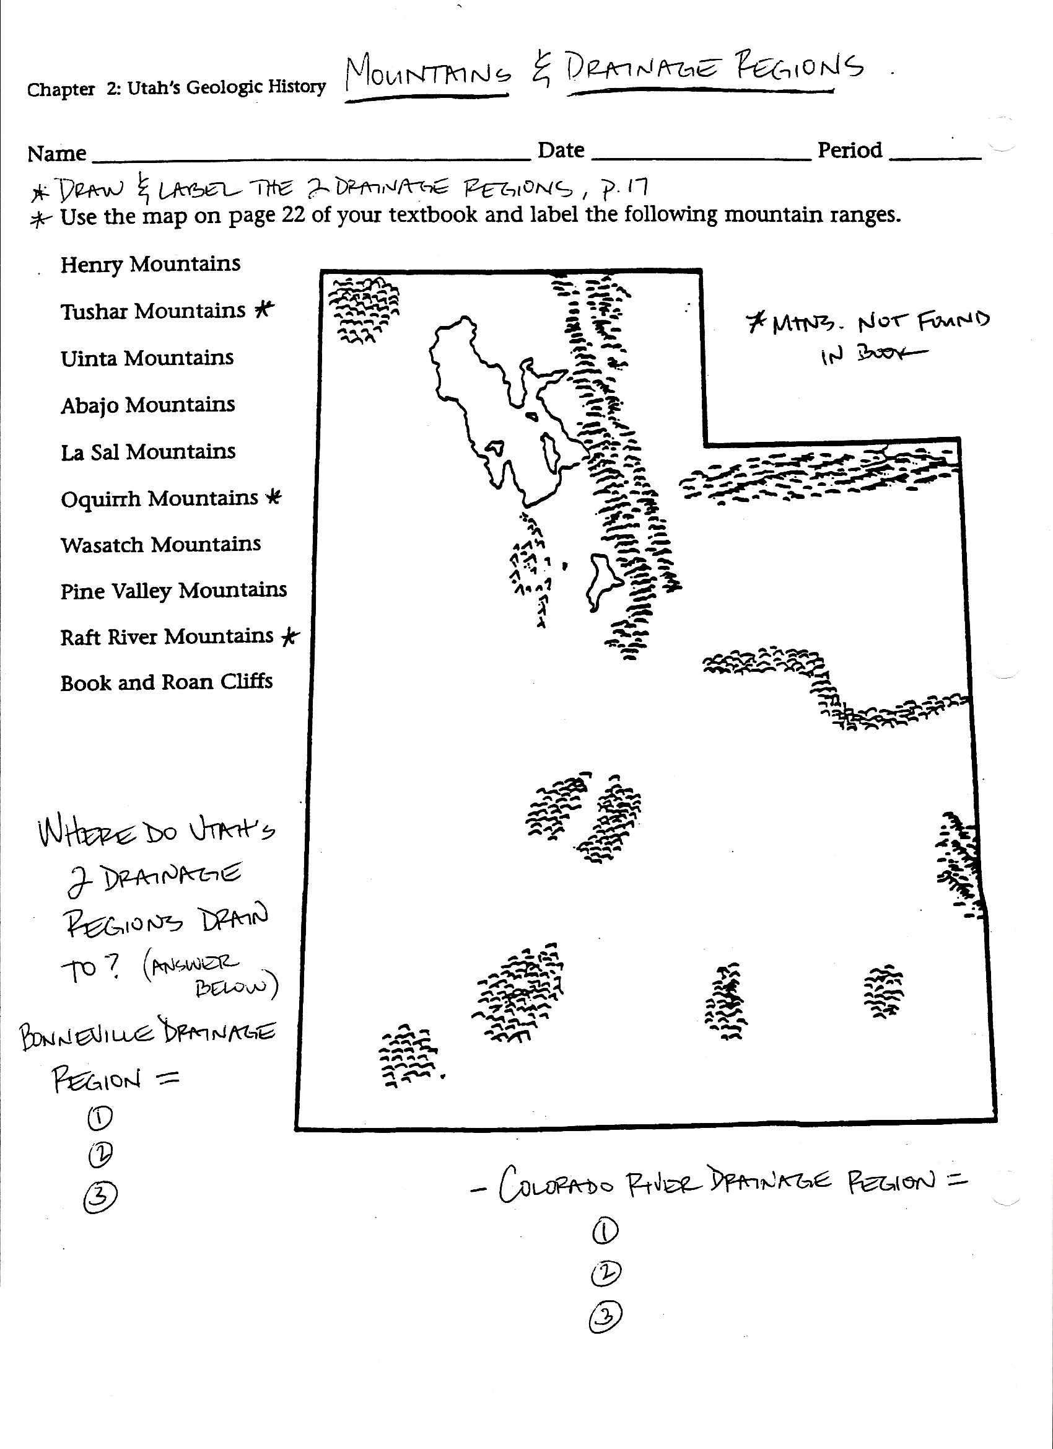

Use the map on page 25 of your textbook and label the following mountain ranges.