Name________________________________________________ Period________Date____________________________
Chapter 5 Passing Through the Great Basin
Manifest Destiny
- John O’ _________________ wrote, “It is the _________________ _____________________of the United States to ________________________ across the _________________________.”
- Means that the United States reached from the ________________________ to the _____________________, including Canada & Mexico.
Bidwell-Bartleson Party
- Bidwell-Bartleson Party was the ____________wagon train party to cross ______________Utah in __________.
Hastings Cutoff
- Lansford W. Hastings suggested a more direct route to ___________________by the __________________ ___________________ ______________________. John C. Fremont agreed it could be done.
Donner Party
- Last group of the year to use _________________ ____________________
- Hacked a road through __________________ ___________________ taking up____________________
- Got trapped in the __________________ __________________ Mountains through Winter and had to ________________dead party members to survive.
Mormon Pioneers
- Mormon -the term most often refers to a member of The Church of Jesus Christ of _____________-______________ __________________
- The Mormon church was founded by a man named _________________ __________________
Joseph Smith
- Claimed he saw a _____________ telling him not to join any of the churches (Palmyra, _____________).
- He claims he was visited by heavenly messengers for a number of years.
- He said he was led to a hillside, found ______________ _________________, translated them, and Mormons are those that believe this is the ________________ of ___________________.
Where does the name Mormon come from?
- The term "____________________________" has its origins in the Book of Mormon, which is believed by Latter Day Saints to be a religious and historical record translated from golden plates by Joseph Smith, Jr. into English by divine inspiration.
- Mormons believe that the Book of Mormon is another ______________________witness of Jesus Christ that is comparable to the________________________, which they also believe to be the word of God
- Bible=________________ Torah=_______________ Koran= _______________
Names to remember
- _______________ _____ _____________ __________ _____ ______________- ________ _______________
- __________________
- __________________
Where do the Mormons start and end up?
- ________________  - ________________  - ________________  - ________________  - ________________  - ________________  - ________________  - ________________ | 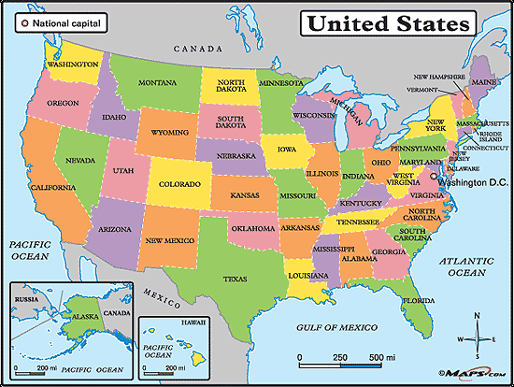

6 Reasons for Mormon persecution
- Mormon’s claim to be the _____________ ________________ ________________
- Some of Church Leaders in Illinois started living in ___________________________
- They _______________________ their _________________________
- Mormons _________________ ___________________ and neighbors feared Mormons would take over politically.
- Mormons were ________________ __________________- Missourians wanted to be a slave state.
- Mormons lived a ____________________ _______________________ -they all gave what they had to the church. This gave leaders a lot of power.

